**Excel capstone project**

**Question 1; which region raked in the most revenue**

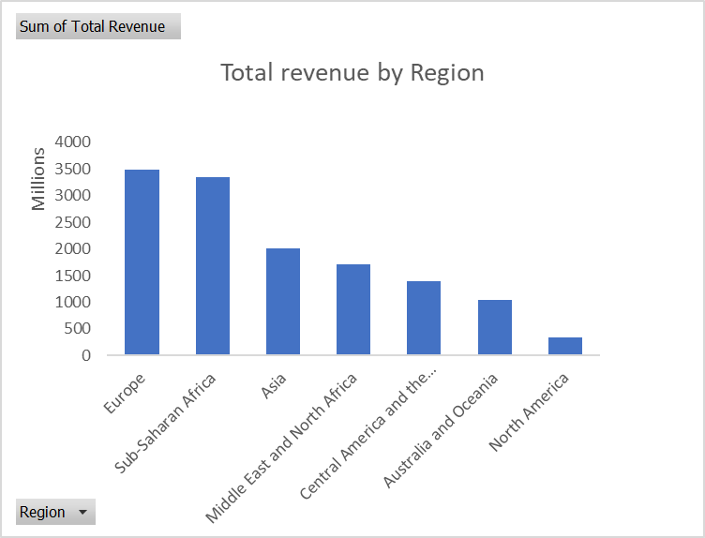

From the chart above, Europe has the highest revenue generation therefore, it is ranked the most revenue region.

**Question 2; who are the top 5 and bottom five countries, based on profit**

|  |  |
| --- | --- |
| **Row Labels** | **Sum of Total Profit** |
| Kiribati | 32454798.26 |
| Qatar | 30861356.79 |
| Grenada | 30302769.9 |
| Taiwan | 30044779.98 |
| Malawi | 29329125.05 |
| **Grand Total** | **152992830** |
|  |  |

The pivot table and chart above show the listof top five countries base on profit

|  |  |
| --- | --- |
| **Row Labels** | **Sum of Total Profit** |
| Tajikistan | 13662027.26 |
| Mali | 13800334.9 |
| Malta | 14163744.55 |
| Italy | 14199991.25 |
| Cape Verde | 14383303.52 |
| **Grand Total** | **70209401.48** |

The pivot table above show the five bottom countries base on profit

**Question 3; display the line chart of the revenue by region across the years, what was the difference between the highest and the lowest regions**

Europe is the region with the highest revenue and North America is the region with the lowest revenue with over $3,146 million difference.

**Question 4; compare the total cost of baby food items purchased by africans and Europeans**

The total cost of baby food in purchased by African countries is higher compare to the European country

**Question 5; how many units of office supplies was sold to the Czech Republic**

|  |  |  |
| --- | --- | --- |
| Q5, | **Row Labels** | **Sum of Units Sold** |
|  | **Office Supplies** | **36086** |
|  | Czech Republic | 36086 |
|  | **Grand Total** | **36086** |

**Question 6; which country brought in the most revenue between 2011-2015**

|  |  |  |
| --- | --- | --- |
| Q6 | **Row Labels** | **Sum of Total Revenue** |
|  | **Taiwan** | **88416183.04** |
|  | 2011 | 18530977.92 |
|  | 2012 | 13621204.69 |
|  | 2013 | 8966920.59 |
|  | 2014 | 26813415.4 |
|  | 2015 | 20483664.44 |
|  | **Grand Total** | **88416183.04** |

**Question 7; which region was the most profitable in 2015**

|  |  |
| --- | --- |
| **Row Labels** | **Sum of Total Profit** |
| **Europe** | **141507971.8** |
| 2015 | 141507971.8 |
| **Grand Total** | **141507971.8** |

**Question 8; which country ordered the most item and what item did they order the most**

|  |
| --- |
| **Row Labels** |
| **Taiwan** |
| **Beverages** |
| M |
| L |
| H |
| C |
| **Grand Total** |

**Question 9; which region and in what country was the least profitable through the online sales channel? Give hypothetical reason why you think they performed poorly through online channel**

|  |  |
| --- | --- |
| **Row Labels** | **Sum of Total Profit** |
| **North America** | **8583988.4** |
| **Canada** | **8583988.4** |
| Online | 8583988.4 |
| **Grand Total** | **8583988.4** |

I think they performed poorly through the online sales channel because the product wasn’t visible enough owning to the fact most customers might not have access to the internet. Also, the poor performance can be based on the product cost factor when compared to the country’s currency.

**Question 10; from which Asian country did we get the most profit in the beverages item.**

|  |  |
| --- | --- |
| **Row Labels** | **Sum of Total Profit** |
| **Asia** | **910237.5** |
| **Taiwan** | **910237.5** |
| Beverages | 910237.5 |
| **Grand Total** | **910237.5** |

**Question 11; compare the units of fruits sold to Nigeria to the units of snacks sold**

**Question 12; looking at the data, what can your advice be to the management in other to increase patronage from the bottom five countries**

A lot of factors might have caused the decrease in profit generated by the five countries.

1; Looking at the sales channel, the most profit generated sales channel is the online sales channel. Therefore, the brewery company could focus more on increasing the publicity of the products and brand through advertising campaigns, sponsoring local events, leveraging social media to reach out on potential clients.

2; Coming down to the order priority, M is the most wanted order. Therefore, I would advise it be made more available and accessible to the customers. The company could customize the product to align with the taste and preferences of this countries by using local ingredients and flavors that appeal with the people of this countries

3; The unit cost price of each product should be considered by subsidizing the cost for each product and even considering promo sales for these countries.

4; The brewery can attract more customers from the bottom five countries by providing unique experiences that set it apart from competitors. The company could organize beer tastings or brewery tours to showcase the brewing process and engage customers.